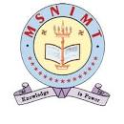

MSN INSTITUTE OF MANAGEMENT & TECHNOLOGY
LIBRARY HANDBOOK
2023-2024
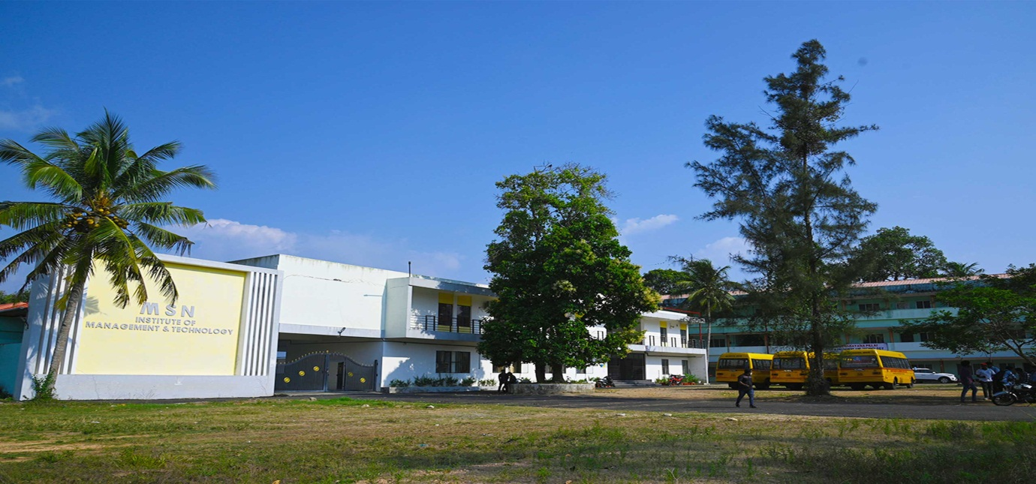

MUKUNDAPURAM PO, CHAVARA, KOLLAM-691585
Web: www.msnimt.org, ph-0476-2683973

TABLE OF CONTENTS

VISION AND MISSION - 3

INTRODUCTION - 3

LIBRARY FLOOR PLAN - 4

LIBRARY OPENING HOURS - 4

LIBRARY RESOURCES - 5-10

FINDING LIBRARY METERIAL - 10-14

LIBRARY FECILITIRS & SERVICES - 14-15

LIBRARY REGULATION - 15-17

STAFF DIRECTORY - 18

Library

VISION AND MISSION
The mission of the Central Library is to facilitate creation of new knowledge through acquisition, organization and dissemination of knowledge resources and providing for value added services.
The library has an excellent collection of books like, Management, Commerce, English Language & Literature, Story books. It maintains separate collections of , Journals and non-book materials ,Reference Books, Standard Bound volumes of Journals, Technical Reports, Previous question papers, CD-ROMSs, DVDs, Periodicals, etc. At present, the library has a collection of around 8,000 Volumes and 4500 Titles of books, Reports and Reference material. Besides standard textbooks, the library contains books of literature and general interest.
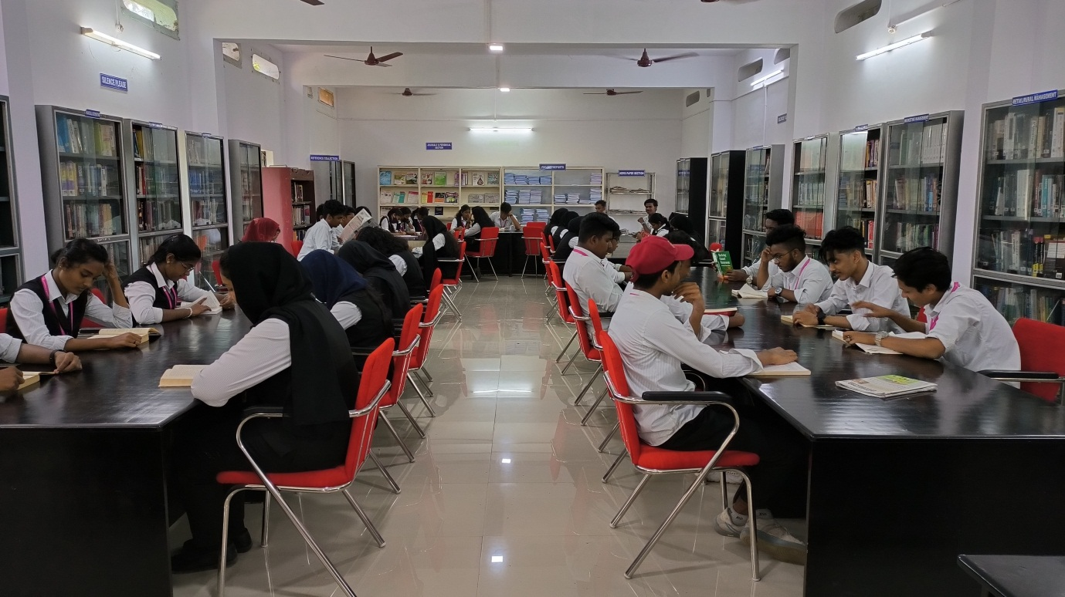
Books are classified and arranged as per Dewey Decimal Classification (DDC), so that members can locate books easily. The library is digitalized and operates on LIBSOFT software. The library is completely computerized and the circulation is based on barcode system.

Consortium / Institutional Membership
- ESS – E-ShodhSindhu by INFLIBNET – Consortium for higher education electronic resources. (Formerly INDEST-AICTE Consortium)
- NDLI Club – Institutional Membership with National Digital Library (NDL) of India
- DELNET – Developing Library Network
A reservoir of Indian Theses (shodhganga)
Apart from the conventional library, there exists a digital library which contains sufficient digital documents such as E-books, E-Journals, Technical Reports, Project Reports, etc. The library has access to around 96 National Journals. The MBCET library access to the 5 set E-journal packages viz. IEEE-ASPP, ASCE, ASME, IEI Journals and Science Direct.
Contact library at library@msnimt.ac.in
MSNIMT Library on Mobile / Web
Digital Database – Developing Library Network (DELNET)
Member Sree Narayana Pillai Institute of Management & Technology library has been integrated with cloud based digital solution wherein all online resources subscribed / purchased by the library can be accessed off-campus anywhere, anytime and any device.
D SPACE URL- http://msnimt.digitalrepository.in
For the first time please login through web so as to change the
password accordingly.
Connect to the library for any queries.
The important library services are:
• DSpace Digital Repository
• Reprographic Facility
• Library Instruction Classes
• SDI – Selective Dissemination Information
• CAS – Current Awareness Service
• OPAC – Online Public Access Catalogue
• On demand literature search

Borrowing Facility
CATEGORY | TYPE | NO OF BOOKS | TIME
Students | B.Com & BA | 4 | 14 days
Students | I MBA & MBA | 6 | 14 days
Faculty | All | 20 | 1 month
Administrative Staff |  | 3 | 1month

Library Timings
Monday –Friday | 9.30 am-4.30-pm
Saturday | 9.30 am-4.00 pm

LIBRARY RESOURCES

Print Collection

The library contains more than 7800 printed books. Classified, catalogued, barcoded and arranged systematically in the shelves with necessary direction boards and labels.

Reference collection

The reference collection consist of standard reference tools such as Dictionaries, Encyclopaedias, Handbooks, Atlases, World record books and the books mentioned in the syllabus as the reference, audio visual materials,CD-ROMS , Previous question papers. Books for civil service coaching, KMAT, CMAT, GATE, QUIZ competition and aptitude test.These reference materials are for use in the library only. Reference materials are indicated by REFERENCE Seal on the title page of the book and the colour of the spin label is red.

Serial collection

Serial collection contains about 150 printed titles, current issues of periodicals are displayed on periodical racks while back issues or bound volumes of periodicals are located on bookshelves separately to the current issues .These are for use in the library only.

Newspapers collection

The library can subscribe 6 newspapers. Current issues of the newspaper are put on the newspaper stand in the library. Back issues are kept at circulation counter.

Digital Collections

The digital library of the college provides abundant learning resources including full text electronic journals, electronic books, data bases, reference resources, and past examination question papers. Our collection includes DELNET, NDL, SWAYAM, Swayamprabha, Shodganga, Institutional digital repository, and digital library managed by D SPACE. Many of our faculty members and students are using National Digital Library (NDL) and doing online course in NPTEL and SWAYAM platforms. Library users can access the electronic collections any time anywhere.

Link to e-resources

DELNET : http://delnet.in/
NPTEL : https://nptel.ac.in/
NPTEL WEB COURSE : https://nptel.ac.in/course.html
PG PATHSHALA https://epgp.inflibnet.ac.in/
IETE : https://www.iete.org/publications.html
NDL : https://ndl.iitkgp.ac.in/
SWAYAM : https://swayam.gov.in/
E-YANTRA :https://www.e-yantra.org/
SWAYAMPRABHA :https://www.swayamprabha.gov.in/
GYANDHARA :https://www.ignouonline.ac.in/gyandhara/
SHODH GANGA :https://shodhganga.inflibnet.ac.in/
OPAC : www.msnimt.libsoft.org

DELNET

DELNET was initially supported by the National Information System for Science and Technology (NISSAT).Department of scientific and Industrial Research Govt of India It was subsequently supported by the National Informatics Centre, Department of Information Technology, Ministry of Communication and Information Technology, Govt of India and the Ministry of Culture, Govt of India.

DELNET has been established with the prime objective of promoting resource sharing among the libraries through the development of a network of libraries. It aims to collect, store, and disseminate information besides offering computerised services to users, to coordinate efforts for suitable collection development and also to reduce unnecessary duplication wherever possible.

DELNET has been actively engaged with the compilation of various Union Catalogues of the resources available in member-libraries. It has already created the Union Catalogue of Books, Union List of Current Periodicals, Union Catalogue of Periodicals, CD-ROM Database, Database of Indian Specialists, Database of Periodical Articles, Union List of Video Recordings, Urdu Manuscripts' Database, Database of Theses and Dissertations, sample databases of language publications using GIST technology and several other databases. The data is being updated in these databases and is growing rapidly. All the DELNET databases have been resident on DELSIS, an in-house software developed on BASIS Plus, an RDBMS, the product of Information Dimensions Inc. of USA which has been provided to DELNET courtesy National Informatics Centre, New Delhi.

The Main Objectives of DELNET are:

• To promote sharing of resources among the libraries by developing a network of libraries, by collecting, storing and disseminating information and by offering computerised services to the users;

• To undertake scientific research in the area of Information Science and Technology, create new systems in the field, apply the results of research and publish them;

• To offer technical guidance to the member-libraries on collecting, storing, sharing and disseminating information;

• To coordinate efforts for suitable collection development and reduce unnecessary duplication wherever possible;

• To facilitate and promote delivery of documents manually or mechanically.

• To establish /facilitate the establishment of referral and /or research centres, and maintain a central online union catalogue of books, serials and non-book materials of all the participating libraries;

• To develop specialised bibliographic database of books, serials and non-book materials;

• To develop databases of projects, specialists and institutions;

• To possess and maintain electronic and mechanical equipment for speedy communication of information and delivery of electronic mail;

• To coordinate with other regional, national and international networks and libraries for exchange of information and documents;

What is NPTEL?

NPTEL is an acronym for National Programme on Technology Enhanced Learning which is an initiative by seven Indian Institutes of Technology (IIT Bombay, Delhi, Guwahati, Kanpur, Kharagpur, Madras and Roorkee) and Indian Institute of Science (IISc) for creating course contents in engineering and science. NPTEL as a project originated from many deliberations between IITs, Indian Institutes of Management (IIMs) and Carnegie Mellon University (CMU) during the years 1999-2003. A proposal was jointly put forward by five IITs (Bombay, Delhi, Kanpur, Kharagpur and Madras) and IISc for creating contents for 100 courses as web based supplements and 100 complete video courses, for forty hours of duration per course. Web supplements were expected to cover materials that could be delivered in approximately forty hours. Five engineering branches (Civil, Computer Science, Electrical, Electronics and Communication and Mechanical) and core science programmes that all engineering students are required to take in their undergraduate engineering programme in India were chosen initially. Contents for the above courses were based on the model curriculum suggested by All India Council for Technical Education (AICTE) and the syllabi of major affiliating Universities in India.

2. Why NPTEL?

• The basic objective of science and engineering education in India is to devise and guide reforms that will transform India into a strong and vibrant knowledge economy. In this context, the focus areas for NPTEL project have been i) higher education, ii) professional education, iii) distance education and iv) continuous and open learning, roughly in that order of preference.

• Manpower requirement for trained engineers and technologists is far more than the number of qualified graduates that Indian technical institutions can provide currently. Among these, the number of institutions having fully qualified and trained teachers in all disciplines being taught forms a small fraction. A majority of teachers are young and inexperienced and are undergraduate degree holders. Therefore, it is important for institutions like IITs, IISc, NITs and other leading Universities in India to disseminate teaching/learning content of high quality through all available media. NPTEL would be among the foremost and an important step in this direction and will use technology for dissemination.

• India needs many more teachers for effective implementation of higher education in professional courses. Therefore, methods for training young and inexperienced teachers to enable them carry out their academic responsibilities effectively are a must. NPTEL contents can be used as core curriculum content for training purposes.

• A large number of students who are unable to attend scholarly institutions through NPTEL will have access to quality content from them. 11 All those who are gainfully employed in industries and all other walks of life and who require continuous training and updating their knowledge can benefit from well-developed and peer-reviewed course contents by the IITs and IISc

National Digital Library of India (NDLI)

About National Digital Library of India

Ministry of Education through information and communication technology has initiated the National Digital Library of India pilot project to develop a framework of virtual repository of learning resources with a single window search facility. Filtered and federated searching is employed to facilitate focused searching is employed to facilitate focused searching so that learners can find out the right resource with last effort and in minimum time.NDL India is designed to hold content of any language and provide support for all academic levels including researchers and lifelong learners, and disciplines, all popular form of access devices and differently abled learners. It is being developed to help students to prepare for entrance and competitive examination, to enable people to learn and prepare from best practice from all over the world and to facilitate researchers to platform inter-linked exploration from multiple sources .The pilot project is devising a framework that is being scaled up with respect to content volume and diversity to serve all levels and disciplines of learners. It is being developed at IIT Kharagpur.

National Digital Library of India (NDLI) is a virtual repository of learning resources which is not just a repository with search/browse facilities but provides a host of services for the learner community.

Who all can be benefited by NDL India?

NDL India has been designed to benefit all kinds of users like students (of all levels), teachers, researchers, librarians, library users, professionals, differently abled users and all other lifelong learners.

There are so many Digital Libraries. How is NDL India different from them?

NDL India will provide a single window search facilities to act as a one-stop shop for all digital resources. Information can be personalized based on the education level, choice of language, difficulty level, media of content and such other factors while other Digital libraries may not include all these choices. This is like a 'customised service' provided in a 24x7 integrated environment to suit a user's requirement and will be like a one-stop shop for all.

There are so many Digital Libraries. How is NDL India different from them?

NDL India will provide a single window search facilities to act as a one-stop shop for all digital resources. Information can be personalized based on the education level, choice of language, difficulty level, media of 13 content and such other factors while other Digital libraries may not include all these choices. This is like a 'customised service' provided in a 24x7 integrated environment to suit a user's requirement and will be like a one-stop shop for all.

SWAYAM

SWAYAM is a programme initiated by Government of India and designed to achieve the three cardinal principles of Education Policy viz., access, equity and quality. The objective of this effort is to take the best teaching learning resources to all, including the most disadvantaged. SWAYAM seeks to bridge the digital divide for students who have hitherto remained untouched by the digital revolution and have not been able to join the mainstream of the knowledge economy.

This is done through an indigenous developed IT platform that facilitates hosting of all the courses, taught in classrooms from 9th class till post-graduation to be accessed by anyone, anywhere at any time. All the courses are interactive, prepared by the best teachers in the country and are available, free of cost to the residents in India. More than 1,000 specially chosen faculty and teachers from across the Country have participated in preparing these courses.

The courses hosted on SWAYAM will be in 4 quadrants – (1) video lecture, (2) specially prepared reading material that can be downloaded/printed (3) self-assessment tests through tests and quizzes and (4) an online discussion forum for clearing the doubts. Steps have been taken to enrich the learning experience by using audio-video and multi-media and state of the art pedagogy / technology. In order to ensure best quality content are produced and delivered, seven National Coordinators have been appointed: They are NPTEL for engineering, UGC for post-graduation education, CEC for under-graduate education, NCERT & NIOS for school education, IGNOU for out of the school students and IIMB for management studies.

Courses delivered through SWAYAM are available free of cost to the learners, however students wanting certifications shall be registered, shall be offered a certificate on successful completion of the course, with a little fee. At the end of each course, there will be an assessment of the student through proctored examination and the marks/grades secured in this exam could be transferred to the academic record of the students. UGC has already issued the UGC (Credit Framework for online learning courses through SWAYAM) Regulation 2016 advising the Universities to identify courses where credits can be transferred on to the academic record of the students for courses done on SWAYAM.

SWAYAM platform is indigenously developed by Ministry of Human Resource Development (MHRD) and All India Council for Technical Education (AICTE) with the help of Microsoft and would be ultimately capable of hosting 2000 courses and 80000 hours of learning: covering school, under-graduate, post-graduate, engineering, law and other professional courses.

E-PG PATHSHALA

e-PG Pathshala is an initiative of the MHRD under its National Mission on Education through ICT (NME-ICT) being executed by the UGC. The content and its quality being the key component of education system, high quality, curriculum-based, interactive e-content in 70 subjects across all disciplines of social sciences, arts, fine arts and humanities, natural & mathematical sciences, linguistics and languages have been developed by the subject experts working in Indian universities and other R & D institutes across the country. Every subject had a team of principal investigator, paper coordinators, content writers, content reviewers, Language editors and multimedia team.

SHODHGANGA

Shodhganga : a reservoir of Indian theses is a digital repository of theses and dissertations submitted to Indian universities. It is maintained by INFLIBNET Centre which is an autonomous Inter-University Centre of the University Grants Commission (UGC) of India, was initially located in the campus of Gujarat University, Ahmedabad. As of January 2013, INFLIBNET Centre has moved to its new institutional building at infocity, Gandhinagar, [1] capital of Gujarat. As on 4 October 2016, as many as 293 universities in India have signed MoUs with the INFLIBNET Centre to participate in the Shodhganga project. A further 13 centrally funded technical institutions have also signed MoUs with the Centre to participate in the Shodhganga project. The full text of all the documents submitted to Shodhganga are available to read and to download in open access to the academic community worldwide. The repository has a collection of 2, 10,661 theses and 6123 synopses. The top five universities in terms of the numbers of theses submitted are Panjab University, Aligarh Muslim University, Jawaharlal Nehru University, Karnataka University and Anna University. The Shodhganga repository was created consequent on the University Grants Commission making it mandatory through regulations issued in June 2009 for all universities to submit soft copies of PhD theses and MPhil dissertations to the UGC for hosting in the INFLIBNET.

OPAC

Online Public Access Catalog (OPAC) designed specifically for searching the collection. It provides basic and advanced searching with multiple display modes, items status and book location display. Before the OPAC can 15 help the users to find materials, users must tell it what type of materials they need. Users have the option of conducting a Simple, Standard or Advanced Search. Click on the specifying tab at the top of the screen. Follow the instructions on the screen for limiting the user search by author, title, subject, call number or other categories. Users also have various options to display the results.

D-SPACE

DSpace digital library software manages our digital collection through which we can access e-books, encyclopaedias, syllabus, previous years question Papers, Videos, photo galleries, etc. Number of collections available different communities in DSpace.

OPEN ACCESS SYSTEM

The library is following open access system; users can directly approach both reference and stack areas without any restriction. This will help them to go through all related books in their area of search.

CLASSIFICATION SYSTEM

Books are classified according to the Dewey Decimal Classification Scheme and arranged on shelves by call number, which can be found in the Online Public Access Catalogue (OPAC)

LIBRARY FACILITIES AND SERVICES
⦿ REFERENCE
⦿ ISSUE, RETURN & RENEW
⦿ E-RESOURCES
⦿ INTERNET FACILITY (Free Wi-Fi) - 655 Mbps
⦿ OPEN ACCESS SYSTEM
⦿ OPAC & WEB OPAC
⦿ OVERNIGHT ISSUE
⦿ DEPARTMENT LIBRARIES – EC, CS, EEE, CE, BT & BM
⦿ BARCODE & AUTOMATED TRANSACTIONS
⦿ BOOK DISINFECTOR
⦿ THEFT CONTROL
⦿ CC TV SURVEILLANCE
⦿ NEW ARRIVALS DISPLAY
⦿ RESEARCH CUBICLES
⦿ CONFERENCE ROOMS FOR DISCUSSIONS
⦿ NEWS PAPER SERVICE
⦿ REPROGRAPHIC SERVICE
⦿ DRINKING WATER
⦿ PROPERTY COUNTER
⦿ RESTROOMS
⦿ FIRE EXTINGUISHER
⦿ LIBSOFT - AUTOMATION
⦿ DDC & - CLASSIFICATION

The Hundred Divisions

Summaries

First Summary

The Ten Main Classes
000 Computer science, information & general works
100 Philosophy & psychology
200 Religion
300 Social sciences
400 Language
500 Science
600 Technology
700 Arts & recreation
800 Literature
900 History & geography

Second Summary

The Hundred Divisions

000 Computer science, knowledge & systems
010 Bibliographies
020 Library & information sciences
030 Encyclopaedias & books of facts
040 [Unassigned]
050 Magazines, journals & serials
060 Associations, organizations & museums
070 News media, journalism & publishing
080 Quotations
090 Manuscripts & rare books
100 Philosophy
110 Metaphysics
120 Epistemology
130 Parapsychology & occultism
140 Philosophical schools of thought
150 Psychology
160 Logic
170 Ethics
180 Ancient, medieval & eastern philosophy
190 Modern western philosophy
200 Religion
210 Philosophy & theory of religion
220 The Bible
230 Christianity & Christian theology
240 Christian practice & observance
250 Christian pastoral practice & religious orders
260 Christian organization, social work & worship

270 History of Christianity
280 Christian denominations
290 Other religions
300 Social sciences, sociology & anthropology
310 Statistics
320 Political science
330 Economics
340 Law
350 Public administration & military science
360 Social problems & social services
370 Education
380 Commerce, communications & transportation
390 Customs, etiquette & folklore
400 Language
410 Linguistics
420 English & Old English languages
430 German & related languages
440 French & related languages
450 Italian, Romanian & related language
460 Spanish & Portuguese languages
470 Latin & Italic languages
480 Classical & Modern Greek languages
490 Other languages
500 Science
510 Mathematics
520 Astronomy
530 Physics
540 Chemistry
550 Earth sciences & geology
560 Fossils & prehistoric life
570 Life sciences; biology
580 Plants (Botany) 590 Animals (Zoology)

600 Technology
610 Medicine & health
620 Engineering
630 Agriculture
640 Home & family management
650 Management & public relations
660 Chemical engineering
670 Manufacturing
680 Manufacture for specific uses
690 Building & construction
700 Arts
710 Landscaping & area planning
720 Architecture
730 Sculpture, ceramics & metalwork
740 Drawing & decorative arts
750 Painting
760 Graphic arts
770 Photography & computer art
780 Music
790 Sports, games & entertainment
800 Literature, rhetoric & criticism
810 American literature in English
820 English & Old English literatures
830 German & related literatures
840 French & related literatures
850 Italian, Romanian & related literatures
860 Spanish & Portuguese literatures
870 Latin & Italic literatures
880 Classical & Modern Greek literatures
890 Other literatures
900 History
910 Geography & travel
920 Biography & genealogy
930 History of ancient world (to ca. 499)
940 History of Europe
950 History of Asia
960 History of Africa
970 History of North America
980 History of South America
990 History of other areas

Library Team
POST | NAME | QUALIFICATION
Librarian | Jayalekshmi L | Bcom,PGDCA,PGDJ,BLISc,MLISc,
Asst.Librarian | Praseetha MT | BA,BLISc,MLISc

