NDLI Club

National Digital Library of India Club (NDLI Club) is an enabler of career progression for students, job seekers, researchers and learners. NDLI Clubs are set up in institutes and nodal bodies, and these Clubs conduct events to facilitate students to develop knowledge, skill and traits beyond regular curriculum which are essential for their progression in respective professional domain. The events may be either physical or virtual. Virtual events are web-based and are conducted through the NDLI Club portal. The events are organized at respective institute level or city/district/state/regional level or all-India level.
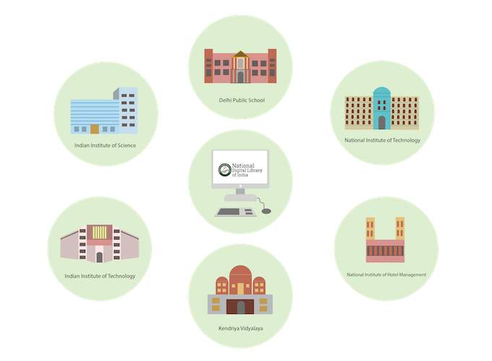
Development of knowledge, skill and traits needs access to varieties of learning resources. NDLI Club members can access a huge repository of free and open access learning resources, from anywhere and at any time, either through desktop PC or laptop or tablet or mobile, from National Digital Library of India (NDLI) (https://www.ndl.gov.in or https://ndl.iitkgp.ac.in). NDLI and NDLI Club are initiatives of Ministry of Education (MOE), Government of India, through its National Mission on Education through Information and Communication Technology (NMEICT). These are National Mission projects and part of Digital India Mission of the country. NDLI provides contents for all academic levels including lifetime learners, all disciplines and in most of the widely used Indian languages, to enable people to learn and prepare from best practices from all over the world.
NDLI and NDLI Club are services that are not just for some, but for all of India to learn, share, grow and democratize education in the country.

A Single-Source Knowledge Repository. A Single-Window Learning Platform.
Meeting India’s complex mix of learning needs spanning from multiple languages, geographies, socio-economic groups to multiple streams and levels of proficiency, through a single-source multi-access knowledge repository.
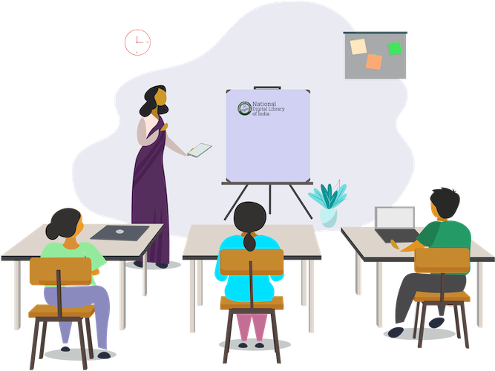

. Learning Beyond Boundaries.
Paving the way to democratize education in the country through digitisation so that not just some, but all of India can Learn, Share and Grow.
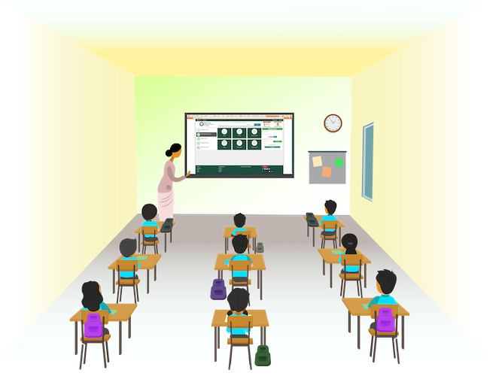

New-Age Multi-Media Education Platform. A Single-Window Learning Platform.
A virtual teaching-learning-evaluation-knowledge discovery and innovation platform to encourage collaborative, personalized, self-paced, new-age multi-media education at all levels.
